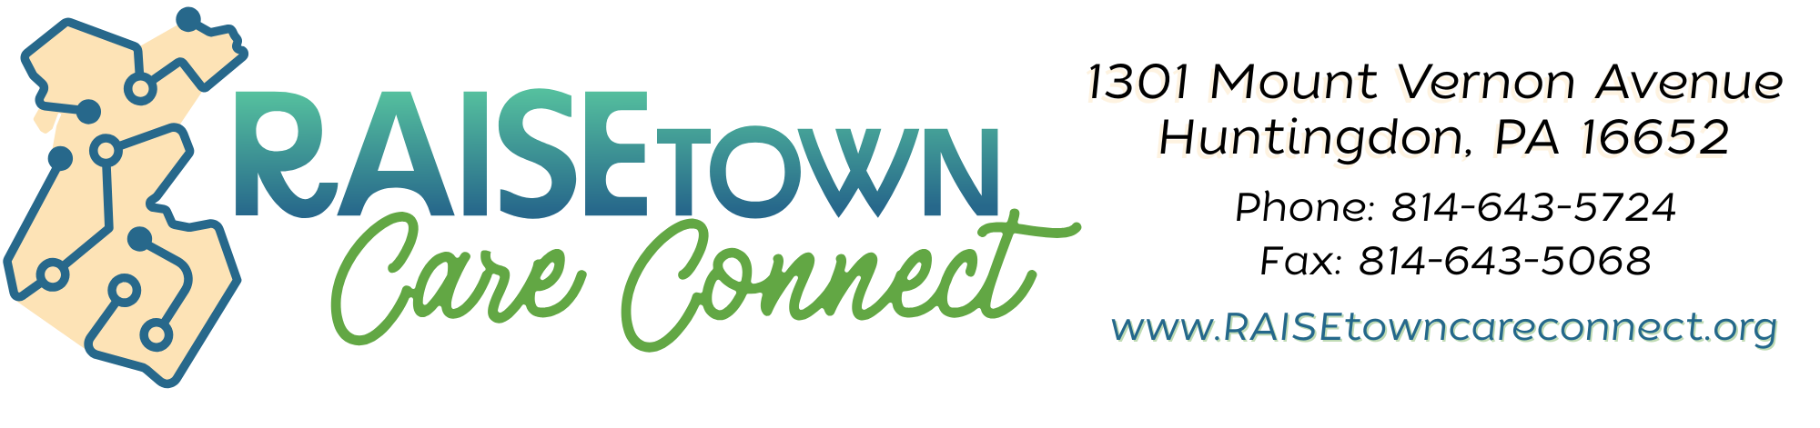
Medical Equipment Rental Agreement
Client Information
Name of Client: ___________________________________ Phone No: __________________
Address: ______________________________________________________________________
Sex: __________ Birthdate: __________ Age: __________ Weight: __________
Medical Problem: _______________________________________________________________
Name of Physician: _____________________________________________________________

Borrower Information
Name of Borrower: _________________________________ Phone No: _______________
Address: ______________________________________________________________________
Relationship to Client: _________________________________________________________

Rental Agreement
RAISEtown Care Connect rents to Borrower, signing this agreement, medical equipment (hospital beds, patient lifts, wheelchairs, knee walkers, walking aides, etc.), subject to all the terms outlined in this Rental Agreement, and Borrower agrees:
- The medical equipment is the property of RAISEtown Care Connect and is in good condition. Borrower shall return equipment in the same condition as when it was loaned to the Borrower (reasonable wear and tear is accepted), at the end of the rental period.

- Prescriptions are required for most medical equipment if it is needed for more than two weeks. The prescription will determine the rental period and whether the client still needs the item. RAISEtown Care Connect will follow up with the Client and Borrower at different intervals to see if the equipment is still being used.

- RAISEtown Care Connect shall not be liable or responsible for the loss of or damage to any property left, lost, damaged, stolen, or transported by the Borrower, its agents, servants, or employees, or any other person on or using the medical equipment, either

Before or after returning it to RAISEtown Care Connect, the borrower assumes all risk of such loss or damage and waives all claims against RAISEtown Care Connect for the reason thereof. The borrower agrees to hold RAISEtown Care Connect harmless from and to defend and indemnify RAISEtown Care Connect against all claims based upon or arising out of such loss or damage.

- Borrower assumes all risk and liability for any loss, damage, or injury, including death to persons or property of Borrower or others, arising out of the use or operation of the medical equipment.

- The borrower is responsible for the medical equipment and will reimburse RAISEtown Care Connect, the legal owner of the equipment, for the full cost of replacement upon demand for any damage, loss, theft, or destruction of the medical equipment.

- Borrower shall defend, indemnify and hold harmless RAISEtown Care Connect, all of their agents, officers, servants, and employees from and against any and all losses, liability claims, damage is, injuries, demands, actions, and causes of action whatsoever, arising out of or related to any loss, damage or injury claimed by persons that may arise from the use, operation or driving of medical equipment, provided that such loss or damage was not caused by the fault or gross negligence and willful misconduct of RAISEtown Care Connect or its employees.

- The borrower assumes all costs and expenses of every kind, including legal fees and disbursements, arising out of and in connection with the use or operation of the medical equipment.

- RAISEtown Care Connect assumes no liability or responsibility for any acts or omissions of Borrower or of Borrower's agents, servants, or employees.

- The borrower shall notify RAISEtown Care Connect immediately of any and all accidents and damage resulting from the use or operation of the medical equipment.

- The borrower agrees to pay all costs, expenses, and attorney fees incurred by RAISEtown Care Connect in collecting sums due, regaining possession of medical equipment, and enforcing or recovering any damage, losses, or claims against the Borrower.

- Borrower of the medical equipment shall, in no event, be deemed to be the agent or employee of RAISEtown Care Connect in any manner or for any purpose whatsoever.

- Any individual executing this agreement as Borrower in a representative capacity shall be bound personally, jointly and severally, with all such fiduciary, corporation, or other entity as to all obligations, expressed or implied, arising hereunder.

- This agreement shall be binding upon the borrower, heirs, and next of kin, executors, administrators, and personal representatives of the undersigned Borrower.

- RAISEtown Care Connect reserves the right to refuse the rental request.

Equipment Loaned
Equipment Name: _____________________________________________ #: _______
Date Loaned: ___________________ Prescription Received: Yes / N/A / Being Sent
Date Returned: ________________ Initials of Staff: ________________

Equipment Name: _____________________________________________ #: _______
Date Loaned: ___________________ Prescription Received: Yes / N/A / Being Sent
Date Returned: ________________ Initials of Staff: ________________

Equipment Name: _____________________________________________ #: _______
Date Loaned: ___________________ Prescription Received: Yes / N/A / Being Sent
Date Returned: ________________ Initials of Staff: ________________

Equipment Name: _____________________________________________ #: _______
Date Loaned: ___________________ Prescription Received: Yes / N/A / Being Sent
Date Returned: ________________ Initials of Staff: ________________

Borrower Responsibility Acknowledgment (Check One):
☐ I am picking up this equipment on behalf of the client and will ensure the client receives and signs the client agreement. I understand the signed client form must be returned to RAISEtown Care Connect.
☐ I, as the borrower, assume full responsibility for the equipment and waive the need for a separate client signature form. I understand that by checking this box, I accept all liability and responsibility for the equipment outlined in the rental agreement.

By signing this, I acknowledge that I have read the rental agreement and understand the terms and conditions set forth herein.
Borrower's Printed Name: ________________________________
Signature: ___________________________________ Date: _________________
RAISEtown Care Connect Staff Signature: ___________________________________

